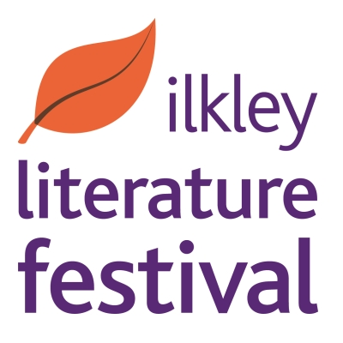
ILKLEY LITERATURE FESTIVAL 2017
YOUNG PEOPLE’S POETRY AND
SHORT STORY COMPETITION

Schools and individual young people in Years 7–13 (ages 11/12-18 inclusive) are welcome to enter this competition, which is for an original poem or short story.

AGE CATEGORIES
Entries will be judged in the following categories:
Years 7, 8 and 9
Years 10 and 11
Years 12 and 13

PRIZES
There will be 1st 2nd and 3rd prizes for Poetry and Short Story in each category unless the judges decide otherwise.
These will include:
A special certificate.
Book tokens for 1st prize winners, kindly provided by Ilkley Book Club and the Grove Bookshop, Ilkley.
Books for 2nd and 3rd prize winners. Runners-up in each category, if the judges decide these are merited, will receive a certificate.
Winners will be invited to read their work at the ‘Cool Voices’ event on Saturday 7 October at 7.15pm at Church House, Ilkley, as part of this year’s Literature Festival.

THE RULES
- One poem and/or one short story per young writer. Please make sure it’s all your own work.
- Please note, you can submit work you did in the Spring or Summer term of 2016.
- Poems or short stories can be on any theme.
- Poems shouldn’t be longer than 28 lines including the title, or they can be as short as you like.
- Short stories shouldn’t be longer than 2,000 words and they can be as short as you like- some of the best short stories are very short!

We are sorry we are unable to offer feedback on individual work or enter into any correspondence regarding judging and selection.

HOW TO ENTER
Fill in the application form (feel free to photocopy).
Attach your work securely to the application form.
Send it to: Young Writers’ Competition
9 The Grove
Ilkley
LS29 9LW

Closing Date: Monday 11 September 2017

ILKLEY LITERATURE FESTIVAL 2017

YOUNG PEOPLE’S POETRY AND SHORT STORY COMPETITION

APPLICATION FORM

Name: ......................................................................................................................

Age: .....................

School: ......................................................................Year Group:..................................

Address where we can contact you:..............................................................................

.........................................................................................................................................

.........................................................................................................................................

Phone number of School for contacting winners or home if individual entry:

.........................................................................................................................................

Please attach your work to this form.

Closing date Monday 11 September 2017.

Send your entry to:

Young People’s Competition
Ilkley Literature Festival
9 The Grove
Ilkley
LS29 9LW

