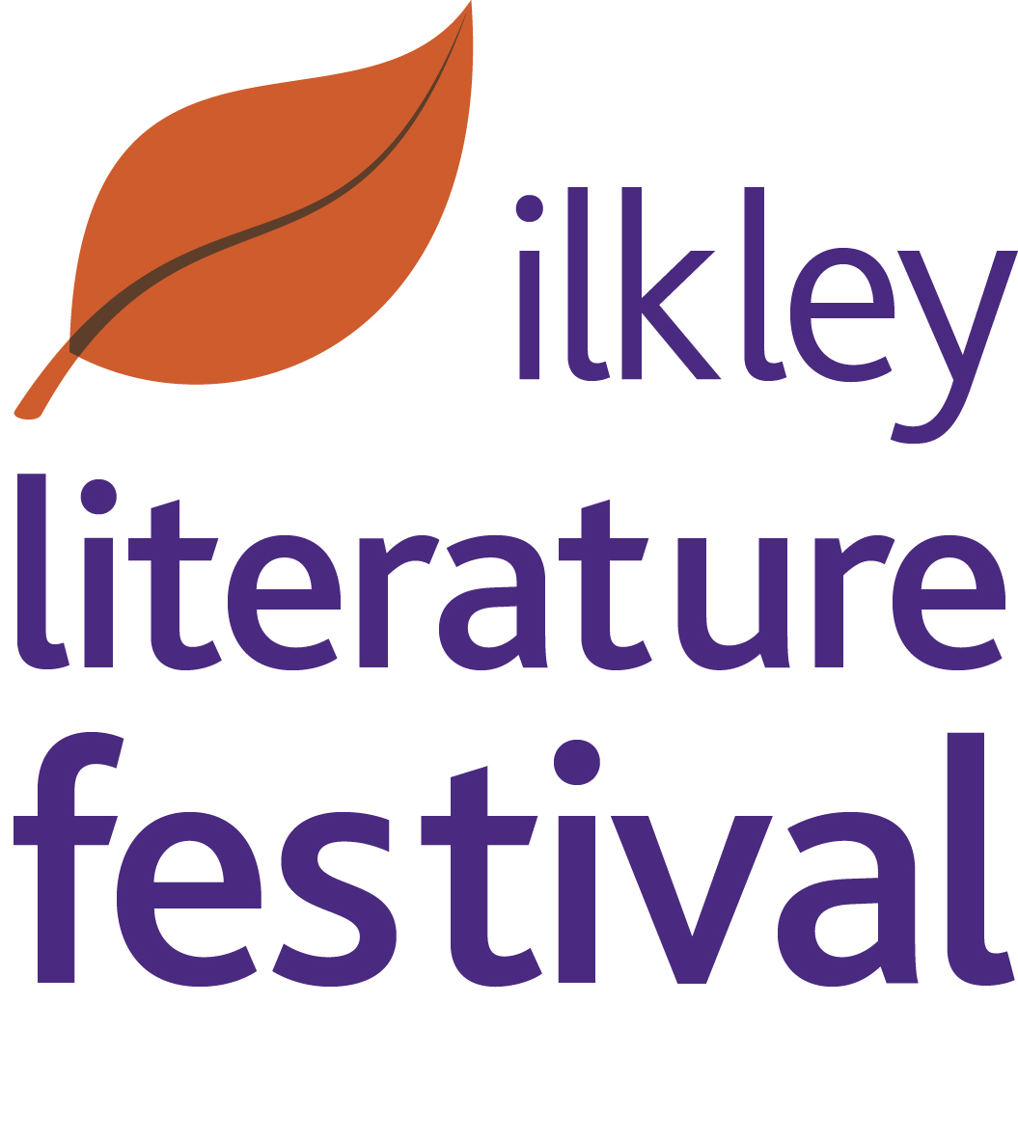

Details of 2018 Apprentice Poet in Residence opportunity

The Festival’s Apprentice Poet in Residence is an opportunity for a talented emerging poet who is based in the Northern region and at the start of their career. As Apprentice Poet in Residence they will shadow this year’s Poet in Residence, Imtiaz Dharker, winner of the Queen’s Gold Medal. The Apprentice will also spend time at Festival events and stage their own Fringe or other reading/event/workshop as appropriate.

Previous Apprentice Poets in Residence include Andrew McMillan who went on to win the Guardian First Book Award; Eric Gregory award winner Phoebe Power, Zodwa Nyoni who went on to be Channel 4 writer in residence at West Yorkshire Playhouse and Mark Pajak, who went on to win a Northern Writer’s Award, an Eric Gregory Award and the Bridport Prize.
As you can see, the Residency offers a great start to your career!

What the Apprenticeship Offers
This is a unique opportunity for a poet based in the region at the start of their career to:
- learn about the role of a Poet in Residence and develop their workshop and liaison skills through shadowing an experienced practitioner
- be part of an exciting and dynamic Festival, using it as a springboard for their future career
- stage their own event in a supported environment, seeing it through all the stages
- try out new ideas
- raise the profile of their work
- meet other poets visiting the Festival

Please note the Apprentice is not under any obligation to produce work during this time although of course they are welcome to do so. The opportunity is focussed on allowing them to soak up as much knowledge as possible within a short period. The Festival is busy, exciting and pressured - with a year’s worth of ideas and energy packed into a few short weeks!

Festival Dates
29 September – 14 October 2018 inclusive. It is up to the Apprentice how many days they spend at the Festival - it is a unique opportunity and Apprentices are normally eager to come to as much as possible.

Financial Support
The Festival offers £500 expenses for up to 17 days during the Festival plus a complimentary ticket for the Apprentice to Festival events. We can also provide a limited amount of accommodation.

The successful candidate will:
- Be based in the Northern region
- Have already had poems published, although won’t yet have published a collection
- Be committed to developing their work and career as a poet
- Have serious emerging talent- the quality of work submitted will be a key factor in determining the apprenticeship.

Role of the Apprentice Poet in Residence
Each previous Apprentice Poet in Residence has contributed their own ideas - from poetry busking to poetry speed dating. The Festival is keen to allow the new Apprentice to come up with their own ideas.
The Apprentice is encouraged to help the Poet in Residence with events and activities eg:
  - readings from say the Bandstand, on Ilkley Moor, by the river or to commuters at the station
  - helping with the poetry networking afternoon
  - attending the Festival’s Multilingual Mushaira

The Apprentice will also have the opportunity to shadow/attend some of the workshops and events delivered by the Poet in Residence for example:
- workshops on writing, reading or enjoying poetry in local primary schools, secondary schools and /or community groups and local poets/interested poetry readers.
- workshop sessions as part of the Festival – in the past these have included one to one poetry surgeries reading contemporary poetry, writing walks and so on.
- Open Mic Competition where poets from across the North compete for the title of Open Mic champion judged by the Poet in Residence.

Admin and Liaison
In liaison with the Festival Director and with support from the Festival Office, the Apprentice will be expected to administer their own events. eg if the Apprentice Poet is keen to set up a reading on the Bandstand they will need to liaise with the relevant local people for permission.

How to Apply
Please send the following to the Festival Office via email (address below)
by 12pm on Wednesday 16 May 2018.

- Your CV which should include:
- info on any poems you have had published in journals, pamphlets, anthologies, or online
- readings you may have done and/or workshops etc you may have led
- two poems
- brief letter outlining what you would like to learn as an Apprentice Poet in Residence and what ideas you have for an event you might want to run at the Festival

Email applications are preferred: info@ilkleyliteraturefestival.org.uk

Postal address for applications: Ilkley Literature Festival
9 The Grove
Ilkley LS29 9LW

Interviews will be held in Ilkley in an evening Thursday 24 May.

For queries: contact the Festival office on 01943 601210 www.ilkleyliteraturefestival.org.uk

