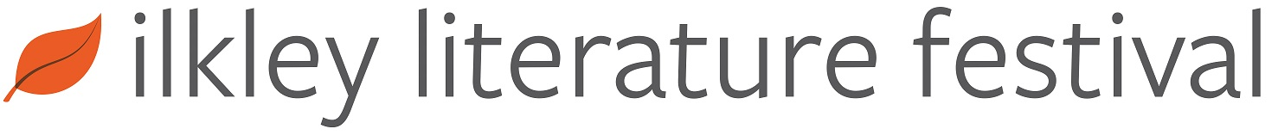

2019 Ilkley Literature Festival Fringe
Application Form

CONTACT DETAILS
Name of Applicant
or Group
Main Contact Name
(if different from above)
Main Contact Telephone | Landline: | Mobile:
Address of Main Contact
Email Address
Website (if applicable)
Proposed Event Title
BACKGROUND INFORMATION
What is your link to the Yorkshire Region?
Have you appeared at Ilkley Literature Festival before? | YES or NO  (If YES please give brief details)
Brief History of your group or your CV highlights if an individual.

EVENT INFORMATION
Number of participants

Type of event
(e.g. poetry reading, pop-up performance, storytelling etc.)
Event description
Include details of what will take place

Showcase your work
Please give links here to any examples of your work online (or attach a video or file to this application and give a description of it here)
Event length
(maximum 1 hour)
Will there be any audience participation? | YES or NO If YES please give details
Is your event suitable for children or young people? | YES or NO Please give details of any age guidelines
Will your event include music? | YES or NO If YES please give details (e.g. live or recorded music, how many musicians, etc.)

How to Apply
Please return your completed 2019 Fringe Application Form to:

Email: fringe@ilkleylitfest.org.uk

Or by post to: Fringe, Ilkley Literature Festival, 9 The Grove, Ilkley, LS29 9LW

Submissions open: 1 April 2019
Closing date: 12pm on 30 April 2019

All selected performers must attend a mandatory Fringe Briefing in early September 2019.

