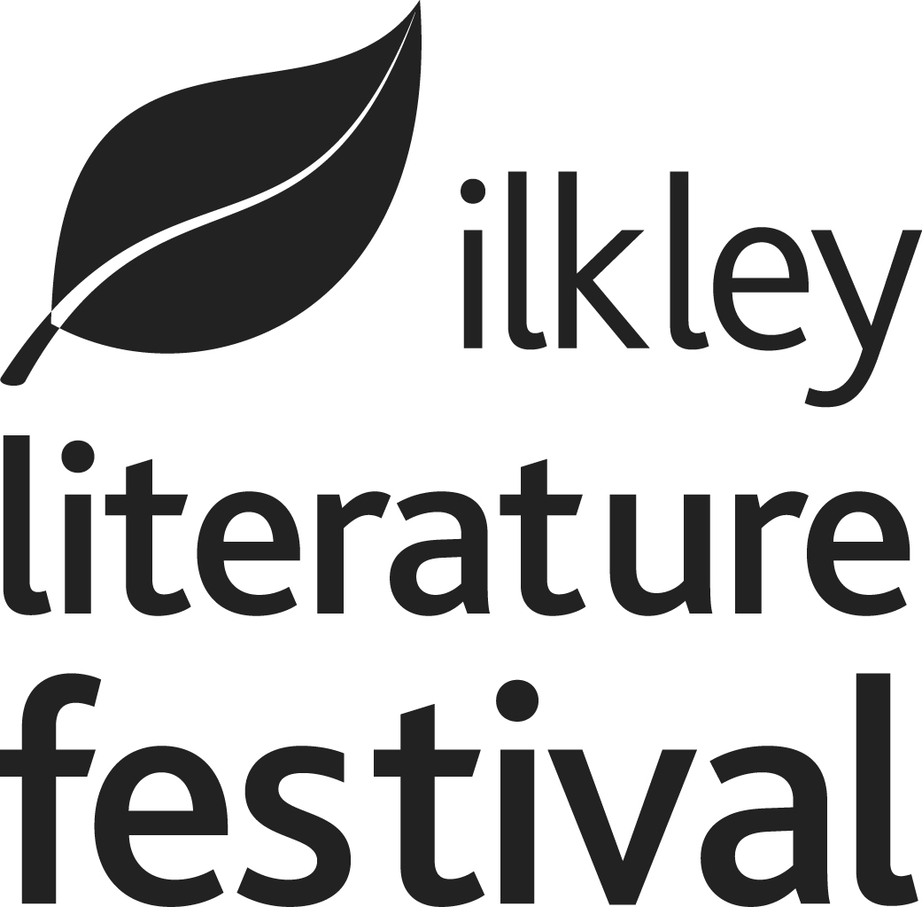

EQUAL OPPORTUNITIES MONITORING- Board Members
Ilkley Literature Festival is committed to providing equal opportunities to all, irrespective of race, colour, creed, ethnic or national origins, gender, marital status, sexuality, disability or age.

As a National Portfolio Organisation, Ilkley Literature Festival is required by Arts Council England to collate statistics on those we collaborate with, our staff and our board. This information will be treated in the strictest confidence and individual data will not be provided to any other party.
Please tick the appropriate box:-
Gender
Male (including male to female trans women)
Female (including female to male trans men)
Non-binary (for example, androgyne)
Prefer not to say
Age
0-19 50-64
20-34 65+
35-49 Not known
Sexuality
Bisexual | Gay woman/ lesbian
Gay man | Heterosexual/ straight
Not known/ prefer not to say

Ethnic background
English/ Welsh/ Scottish/  Northern Irish/ British | Bangladeshi
Irish | Chinese
Gypsy or Irish Traveller | Any other Asian background
Any other White background | African
White and Black Caribbean | Caribbean
White and Black African | Any other Black/ African/  Caribbean Background
White and Asian | Arab
Any other Mixed/ Multiple  ethnic background | Any other ethnic group
Indian | Not known/ prefer not to say
Pakistani
Disabilities
Non-disabled | Cognitive or learning disabilities
Visual impairment | Mental health condition
Hearing impairment/ deaf | Not known/ prefer not to say
Physical disabilities | Other long term/ chronic conditions

